**Implement custom translation**

Custom Translator is a feature of the [Azure AI Translator](https://learn.microsoft.com/en-us/azure/ai-services/translator/translator-overview) service, which enables enterprises, app developers, and language service providers to build customized neural machine translation (NMT) systems. The customized translation systems seamlessly integrate into existing applications, workflows, and websites.

Translation systems built with [Custom Translator](https://portal.customtranslator.azure.ai/) are available through Microsoft Translator [Microsoft Translator Text API V3](https://learn.microsoft.com/en-us/azure/ai-services/translator/reference/v3-0-translate?tabs=curl), the same cloud-based, secure, high performance system powering billions of translations every day.

The platform enables users to build and publish custom translation systems to and from English. Custom Translator supports more than three dozen languages that map directly to the languages available for NMT.

**Features**

Custom Translator provides different features to build custom translation system and later access it.

**Custom Translator key terms**



**What is a BLEU score?**

BLEU (Bilingual Evaluation Understudy) is an algorithm for evaluating the precision or accuracy of text that is machine translated from one language to another. Custom Translator uses the BLEU metric as one way of conveying translation accuracy.

A BLEU score is a number between zero and 100. A score of zero indicates a low quality translation where nothing in the translation matched the reference. A score of 100 indicates a perfect translation that is identical to the reference. It's not necessary to attain a score of 100 - a BLEU score between 40 and 60 indicates a high-quality translation.

**Build, publish, and translate with custom models**

**Prerequisites**

To use the [Custom Translator](https://portal.customtranslator.azure.ai/) portal, you need the following resources:

* A [Microsoft account](https://signup.live.com/).
* Azure subscription - [Create one for free](https://azure.microsoft.com/free/cognitive-services/)
* Once you have an Azure subscription, [create a Translator resource](https://portal.azure.com/#create/Microsoft.CognitiveServicesTextTranslation) in the Azure portal to get your key and endpoint. After it deploys, select **Go to resource**.
  + You need the key and endpoint from the resource to connect your application to the Translator service. Paste your key and endpoint into the code later in the quickstart. You can find these values on the Azure portal **Keys and Endpoint** page:

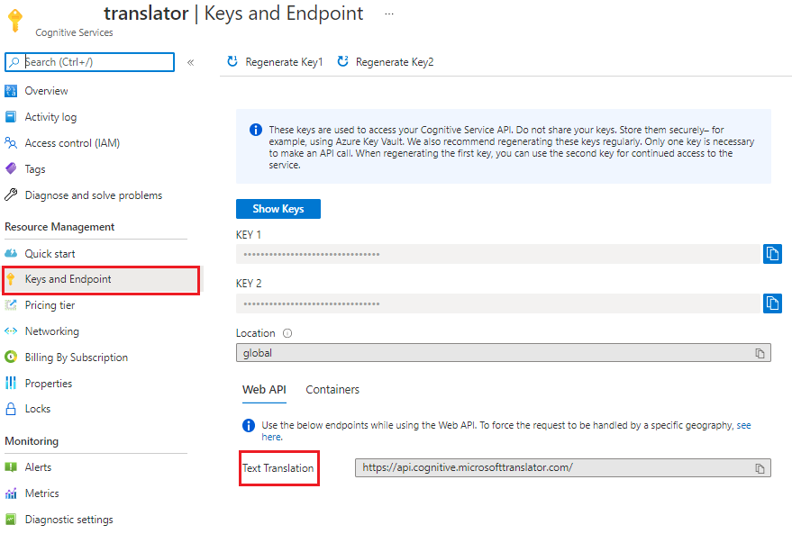

**Process summary**

1. [**Create a workspace**](https://learn.microsoft.com/en-us/azure/ai-services/translator/custom-translator/quickstart#create-a-workspace). A workspace is a work area for composing and building your custom translation system. A workspace can contain multiple projects, models, and documents. All the work you do in Custom Translator is done inside a specific workspace.
2. [**Create a project**](https://learn.microsoft.com/en-us/azure/ai-services/translator/custom-translator/quickstart#create-a-project). A project is a wrapper for models, documents, and tests. Each project includes all documents that are uploaded into that workspace with the correct language pair. For example, if you have both an English-to-Spanish project and a Spanish-to-English project, the same documents are included in both projects.
3. [**Upload parallel documents**](https://learn.microsoft.com/en-us/azure/ai-services/translator/custom-translator/quickstart#upload-documents). Parallel documents are pairs of documents where one (target) is the translation of the other (source). One document in the pair contains sentences in the source language and the other document contains sentences translated into the target language. It doesn't matter which language is marked as "source" and which language is marked as "target"—a parallel document can be used to train a translation system in either direction.
4. [**Train your model**](https://learn.microsoft.com/en-us/azure/ai-services/translator/custom-translator/quickstart#train-your-model). A model is the system that provides translation for a specific language pair. The outcome of a successful training is a model. When you train a model, three mutually exclusive document types are required: training, tuning, and testing. If only training data is provided when queuing a training, Custom Translator automatically assembles tuning and testing data. It uses a random subset of sentences from your training documents, and excludes these sentences from the training data itself. A 10,000 parallel sentence is the minimum requirement to train a model.
5. [**Test (human evaluate) your model**](https://learn.microsoft.com/en-us/azure/ai-services/translator/custom-translator/quickstart#test-your-model). The testing set is used to compute the [BLEU](https://learn.microsoft.com/en-us/azure/ai-services/translator/custom-translator/beginners-guide#what-is-a-bleu-score) score. This score indicates the quality of your translation system.
6. [**Publish (deploy) your trained model**](https://learn.microsoft.com/en-us/azure/ai-services/translator/custom-translator/quickstart#publish-your-model). Your custom model is made available for runtime translation requests.
7. [**Translate text**](https://learn.microsoft.com/en-us/azure/ai-services/translator/custom-translator/quickstart#translate-text). Use the cloud-based, secure, high performance, highly scalable Microsoft Translator [Text API V3](https://learn.microsoft.com/en-us/azure/ai-services/translator/reference/v3-0-translate?tabs=curl) to make translation requests.

**Create a workspace**

1. After your sign-in to Custom Translator, you'll be asked for permission to read your profile from the Microsoft identity platform to request your user access token and refresh token. Both tokens are needed for authentication and to ensure that you aren't signed out during your live session or while training your models.  
   Select **Yes**.

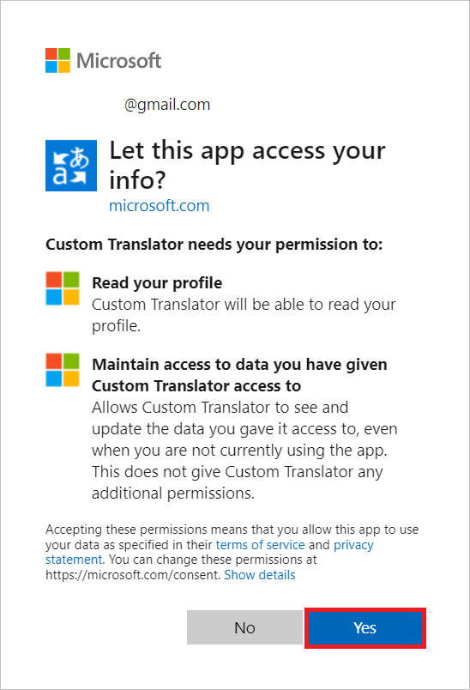

1. Select **My workspaces**.
2. Select **Create a new workspace**.
3. Type *Contoso MT models* for **Workspace name** and select **Next**.
4. Select "Global" for **Select resource region** from the dropdown list.
5. Copy/paste your Translator Services key.
6. Select **Next**.
7. Select **Done**.

**Note :** Region must match the region that was selected during the resource creation. You can use **KEY 1** or **KEY 2.**

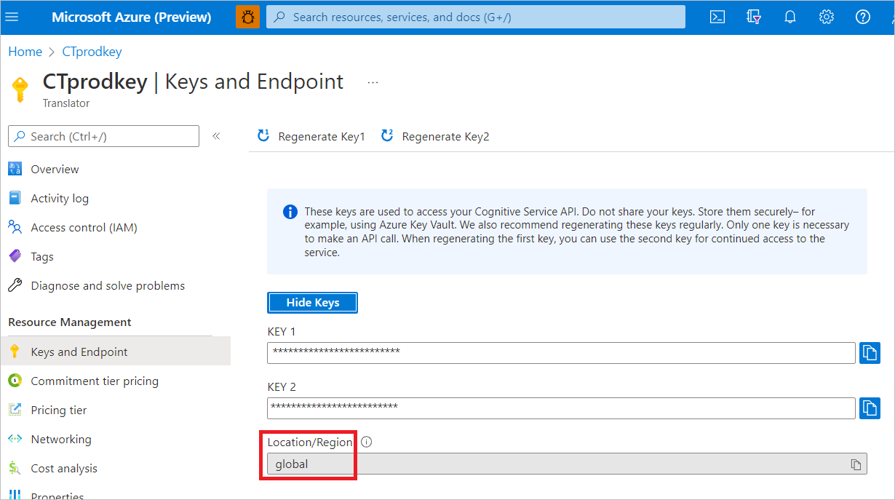

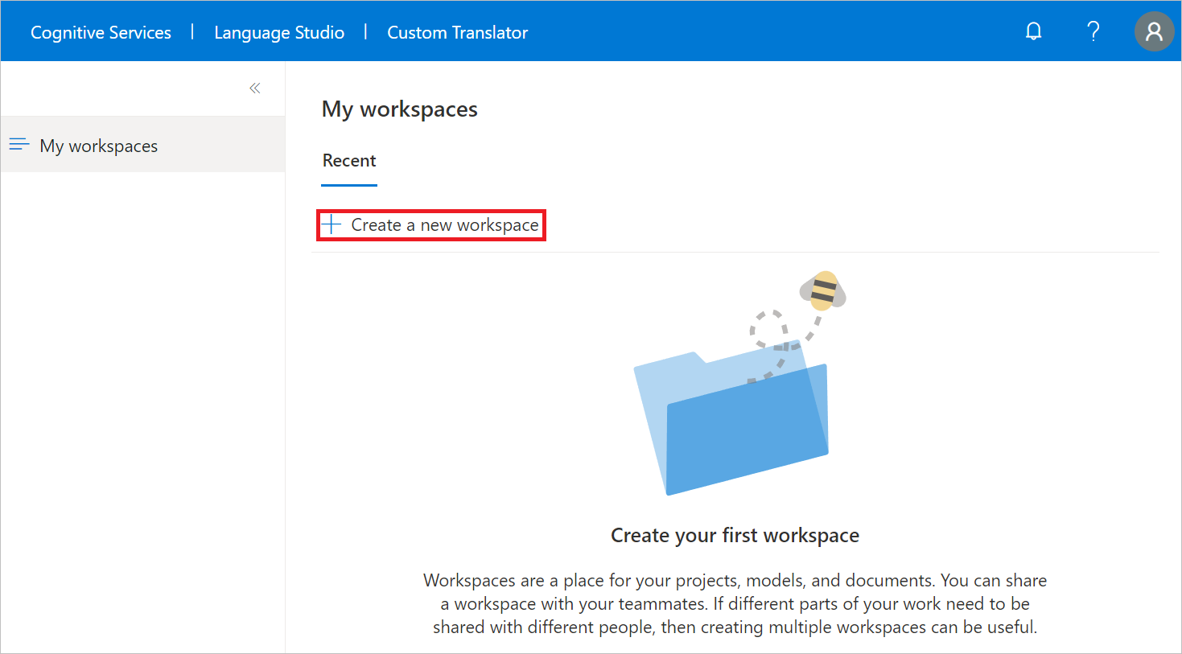

**Create a project**

Once the workspace is created successfully, you see the **Projects** page.

You create English-to-German project to train a custom model with only a [training](https://learn.microsoft.com/en-us/azure/ai-services/translator/custom-translator/concepts/model-training#training-document-type-for-custom-translator) document type.

1. Select **Create project**.
2. Type *English-to-German* for **Project name**.
3. Select *English (en)* as **Source language** from the dropdown list.
4. Select *German (de)* as **Target language** from the dropdown list.
5. Select *General* for **Domain** from the dropdown list.
6. Select **Create project**.

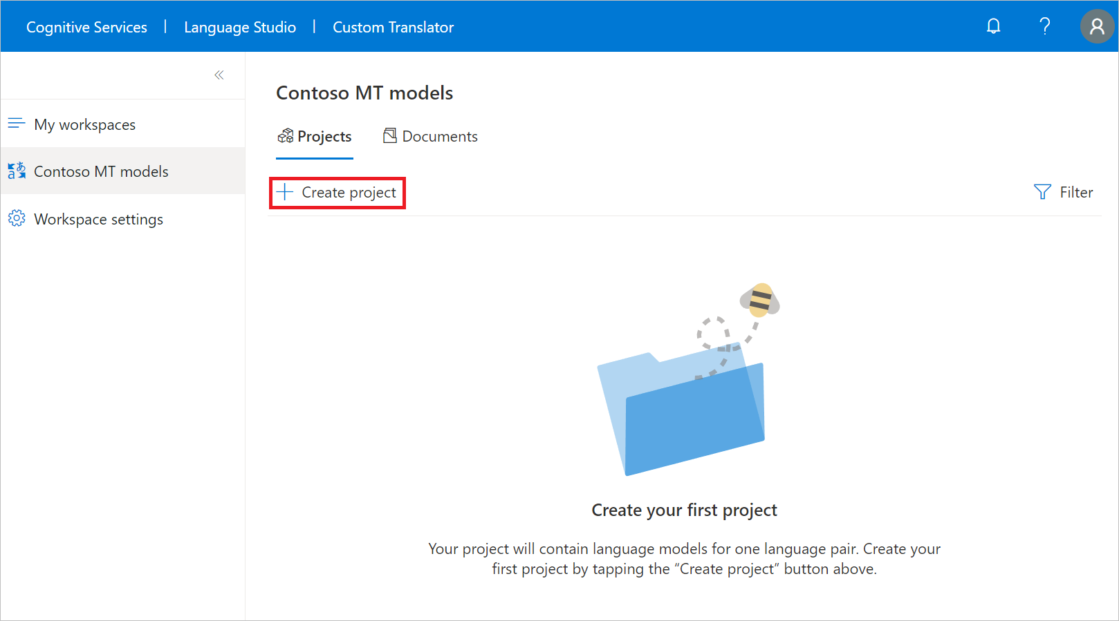

**Upload documents**

In order to create a custom model, you need to upload all or a combination of [training](https://learn.microsoft.com/en-us/azure/ai-services/translator/custom-translator/concepts/model-training#training-document-type-for-custom-translator), [tuning](https://learn.microsoft.com/en-us/azure/ai-services/translator/custom-translator/concepts/model-training#tuning-document-type-for-custom-translator), [testing](https://learn.microsoft.com/en-us/azure/ai-services/translator/custom-translator/concepts/model-training#testing-dataset-for-custom-translator), and [dictionary](https://learn.microsoft.com/en-us/azure/ai-services/translator/custom-translator/concepts/dictionaries) document types.

In this quickstart, we show you how to upload [training](https://learn.microsoft.com/en-us/azure/ai-services/translator/custom-translator/concepts/model-training#training-document-type-for-custom-translator) documents for customization.

**Note :** You can use our sample training, phrase and sentence dictionaries dataset, [**Customer sample English-to-German datasets**](https://github.com/MicrosoftTranslator/CustomTranslatorSampleDatasets), for this quickstart. However, for production, it's better to upload your own training dataset.

1. Select *English-to-German* project name.
2. Select **Manage documents** from the left navigation menu.
3. Select **Add document set**.
4. Check the **Training set** box and select **Next**.
5. Keep **Parallel documents** checked and type *sample-English-German*.
6. Under the **Source (English - EN) file**, select **Browse files** and select *sample-English-German-Training-en.txt*.
7. Under **Target (German - EN) file**, select **Browse files** and select *sample-English-German-Training-de.txt*.
8. Select **Upload**

**Note :** You can upload the sample phrase and sentence dictionaries dataset. This step is left for you to complete.

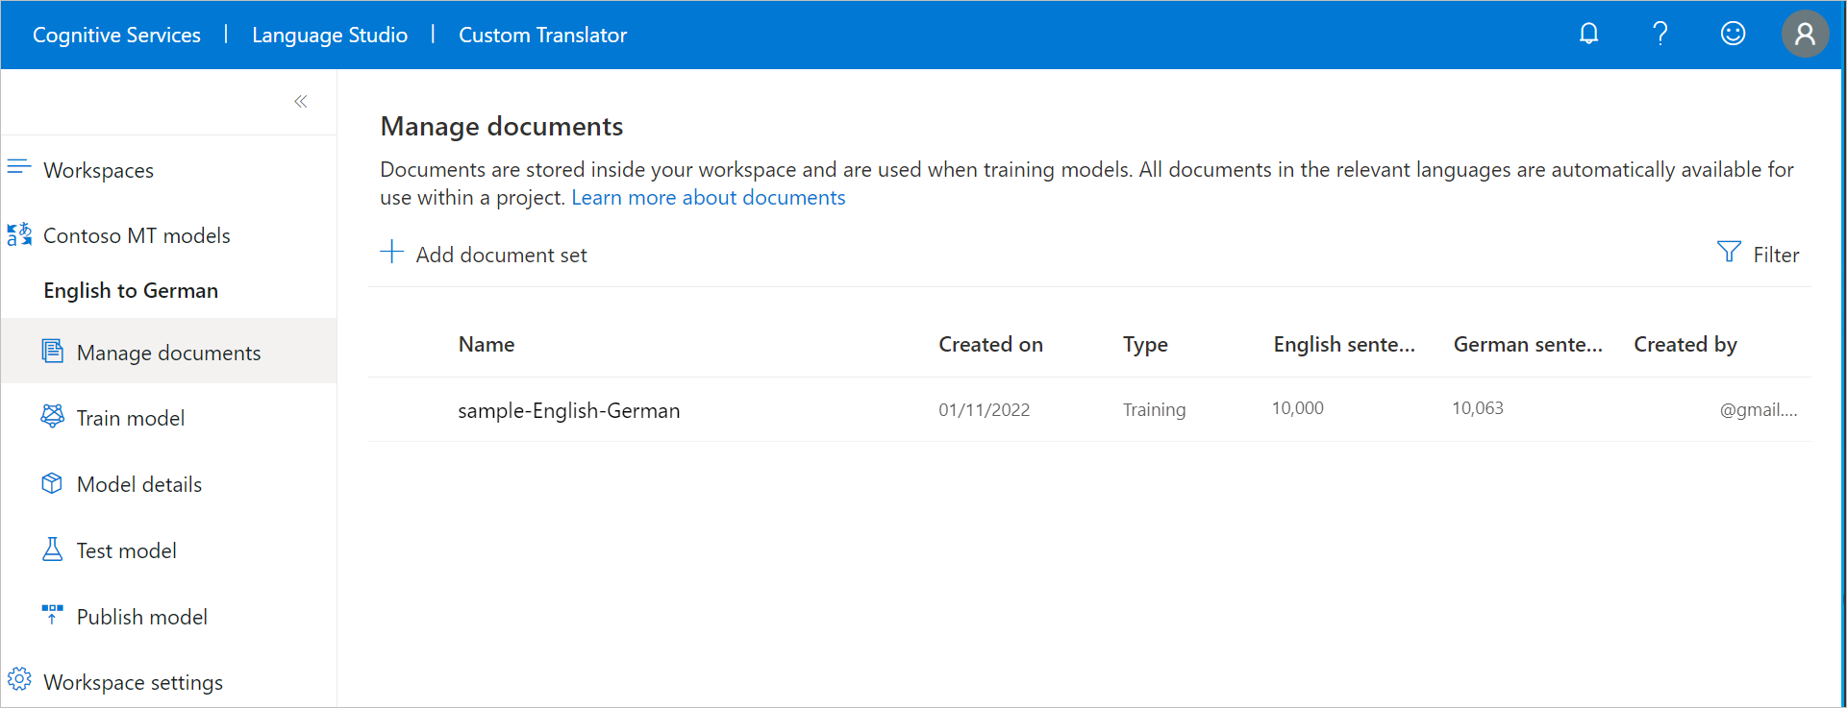

**Train your model**

Now you're ready to train your English-to-German model.

1. Select **Train model** from the left navigation menu.
2. Type *en-de with sample data* for **Model name**.
3. Keep **Full training** checked.
4. Under **Select documents**, check *sample-English-German* and review the training cost associated with the selected number of sentences.
5. Select **Train now**.
6. Select **Train** to confirm.

**Note : Notifications** displays model training in progress, e.g., **Submitting data** state. Training model takes few hours, subject to the number of selected sentences.

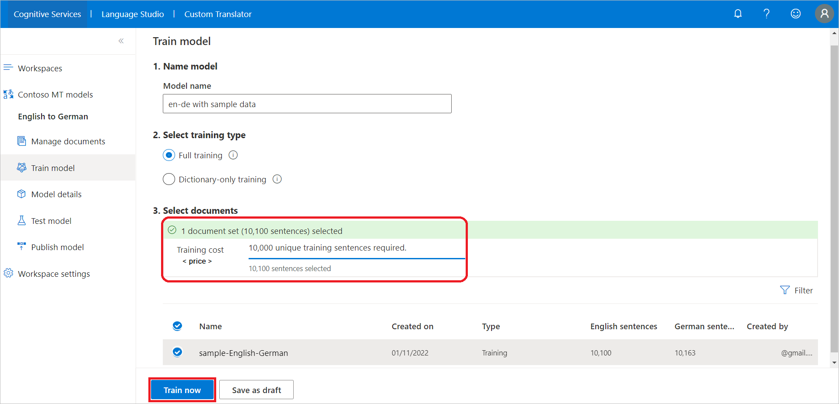

1. After successful model training, select **Model details** from the left navigation menu.
2. Select the model name *en-de with sample data*. Review training date/time, total training time, number of sentences used for training, tuning, testing, and dictionary. Check whether the system generated the test and tuning sets. You use the Category ID to make translation requests.
3. Evaluate the model [BLEU](https://learn.microsoft.com/en-us/azure/ai-services/translator/custom-translator/beginners-guide#what-is-a-bleu-score) score. The test set **BLEU score** is the custom model score and **Baseline BLEU** is the pretrained baseline model used for customization. A higher **BLEU score** means higher translation quality using the custom model.

**Note :** If you train with our shared customer sample datasets, BLEU score will be different than the image.

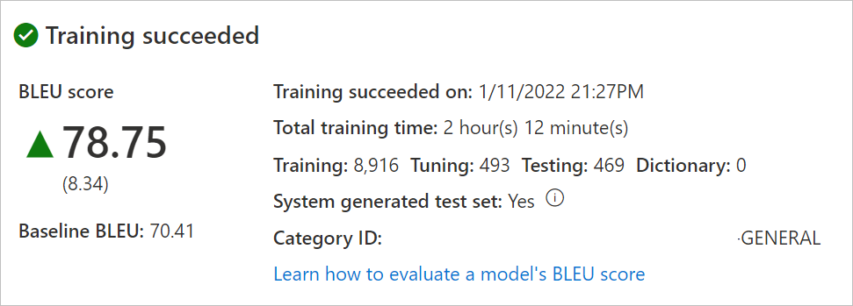

**Test your model**

Once the training completes successfully, inspect the test set translated sentences.

1. Select **Test model** from the left navigation menu.
2. Select "en-de with sample data"
3. Human evaluate translation from **New model** (custom model), and **Baseline model** (our pretrained baseline used for customization) against **Reference** (target translation from the test set)

**Publish your model**

Publishing your model makes it available for use with the Translator API. A project might have one or many successfully trained models. You can only publish one model per project; however, you can publish a model to one or multiple regions depending on your needs. For more information, see [Translator pricing](https://azure.microsoft.com/pricing/details/cognitive-services/translator/#pricing).

1. Select **Publish model** from the left navigation menu.
2. Select *en-de with sample data* and select **Publish**.
3. Check the desired regions.
4. Select **Publish**. The status should transition from *Deploying* to *Deployed*.

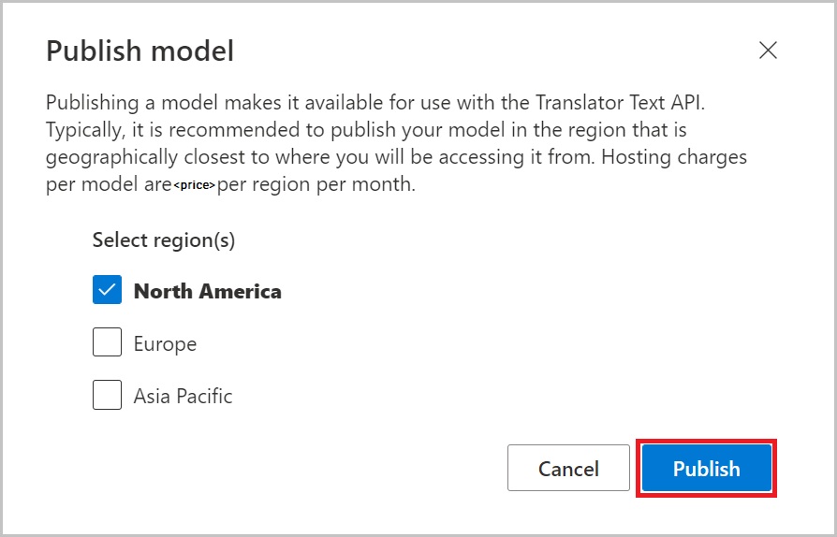

**Translate text**

1. Developers should use the Category ID when making translation requests with Microsoft Translator [Text API V3](https://learn.microsoft.com/en-us/azure/ai-services/translator/reference/v3-0-translate?tabs=curl). More information about the Translator Text API can be found on the [API Reference](https://learn.microsoft.com/en-us/azure/ai-services/translator/reference/v3-0-reference) webpage.
2. Business users may want to download and install our free [DocumentTranslator app for Windows](https://github.com/MicrosoftTranslator/DocumentTranslation/releases).